Acknowledgements
Many thanks to the editors of this special issue for their kind invitation and their patience in awaiting my contribution. I thank them for their insightful suggestions and help in pruning an overgrown essay. I also thank the two anonymous referee for great feedback. Especial thanks to Caroline Schuster for her excellent essay on Gender and COVID-19 and for introducing me to some of the best writing in the field. I thank Fiona Jenkins for conversations about shared concerns and her astute philosophical mind. As always, my thanks to Carolyn Brewer for her comments and her meticulous editing and assistance with references and image permissions. Finally, I thank the Australian Research Council for funding of research for this essay through the Discovery grant Engendering Climate Change, Reframing Futures in Oceania (DP180104224) and The Australian National University for support over decades.
List of Figures
Figure One. Smoke pall in Canberra as seen from Pearce, December 2019
Source. Photo by Darja Hoenigman (with permission)

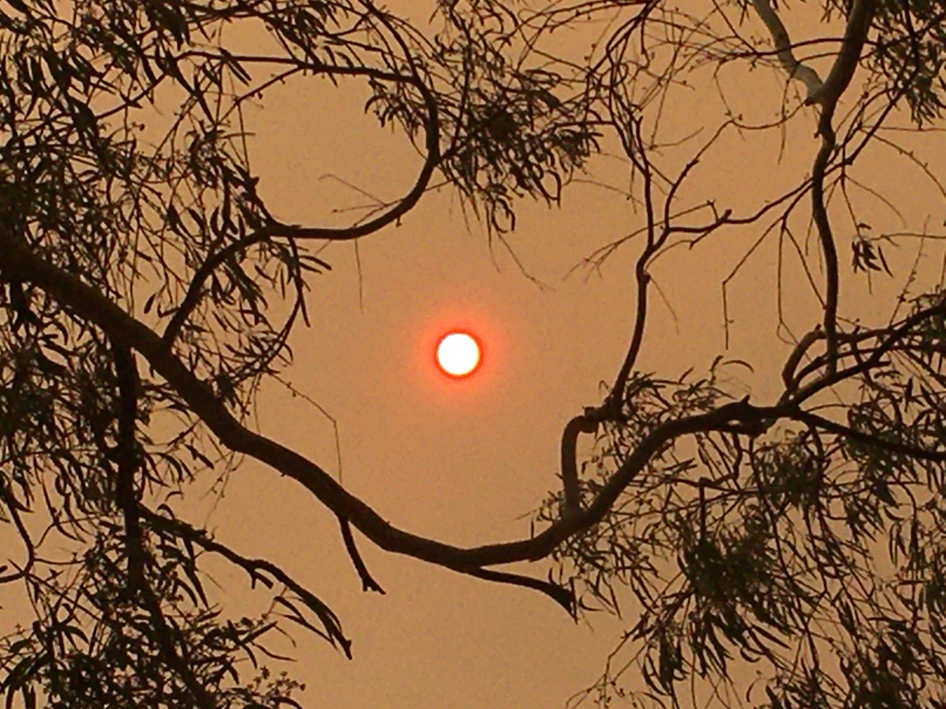

Figure Two. Australia’s Black Summer, Malua Bay Beach, NSW, New Years Day, 1 January 2020. Crowds of people taking refuge with their animals.
Source. Photo by Alex Coppel (permission granted)

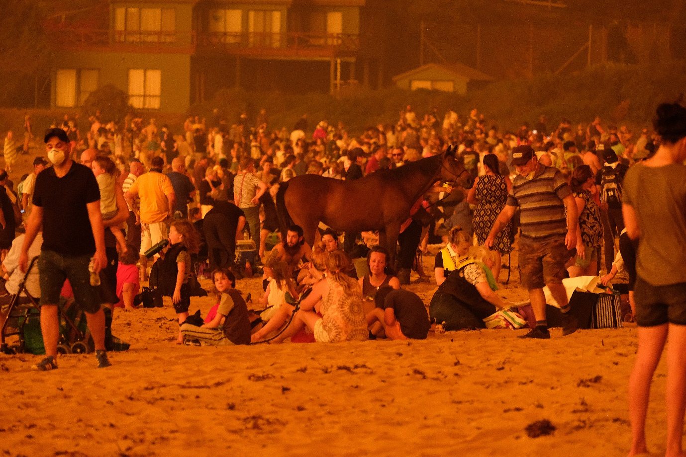

Figure Three. Temperature Rise since 1910 in Australia
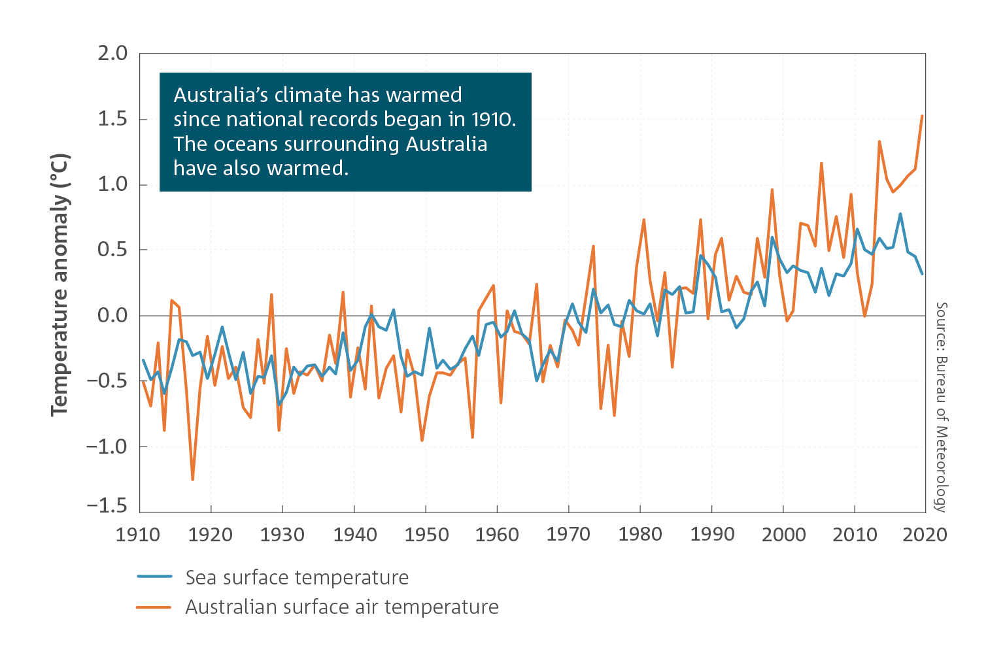

Source. Bureau of Meteorology and CSIRO State of the Climate 2020, available on April 29, 2021 at: http://www.bom.gov.au/state-of-the-climate/

Figure Four. COVID-19 cases and deaths in Australia

Australia

Coronavirus Cases: 29,769

Deaths: 910

Recovered: 28,583

Source. Worldometer Corona Virus, Australia, 29 April 2021, available on April 29, 2021 at: https://www.worldometers.info/coronavirus/country/australia/

